**Student Dashboard**

**Snapshots of the website**

**Sign Up**

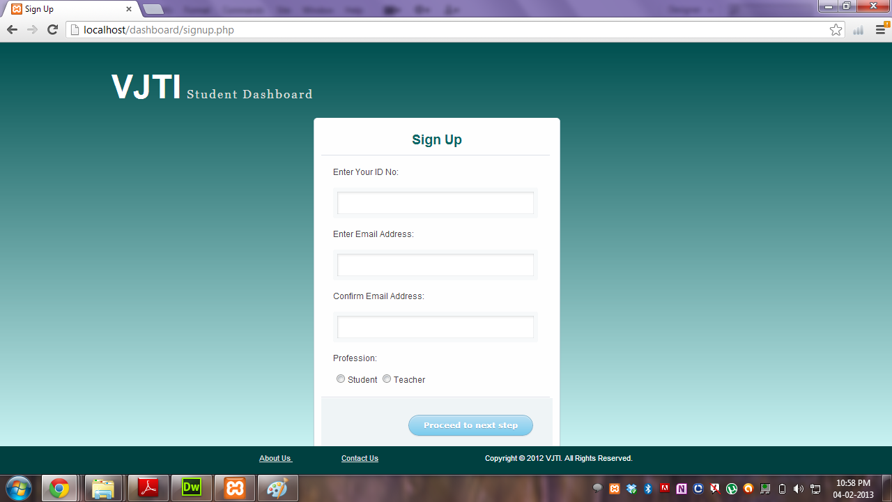

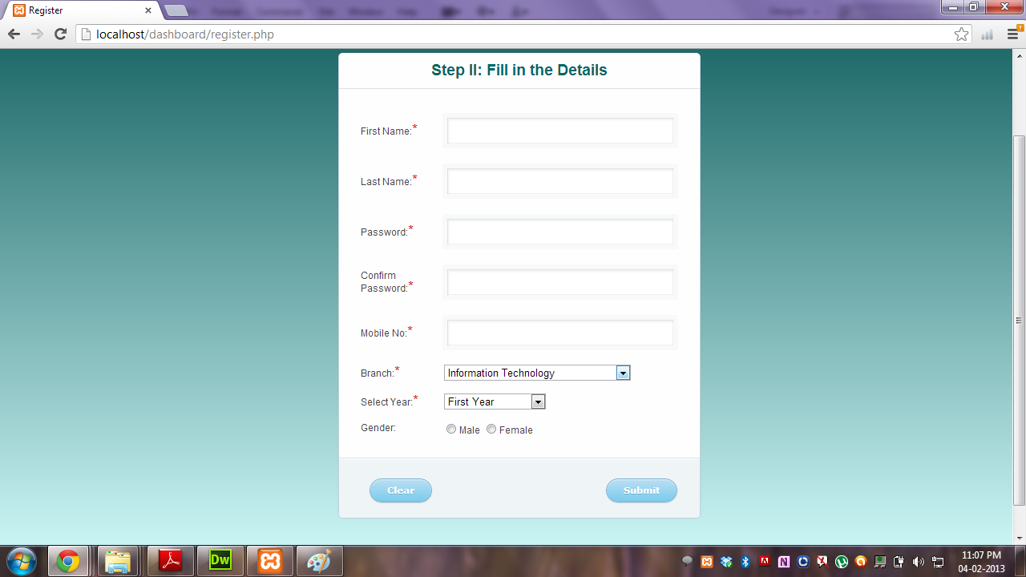

**Signup Error**

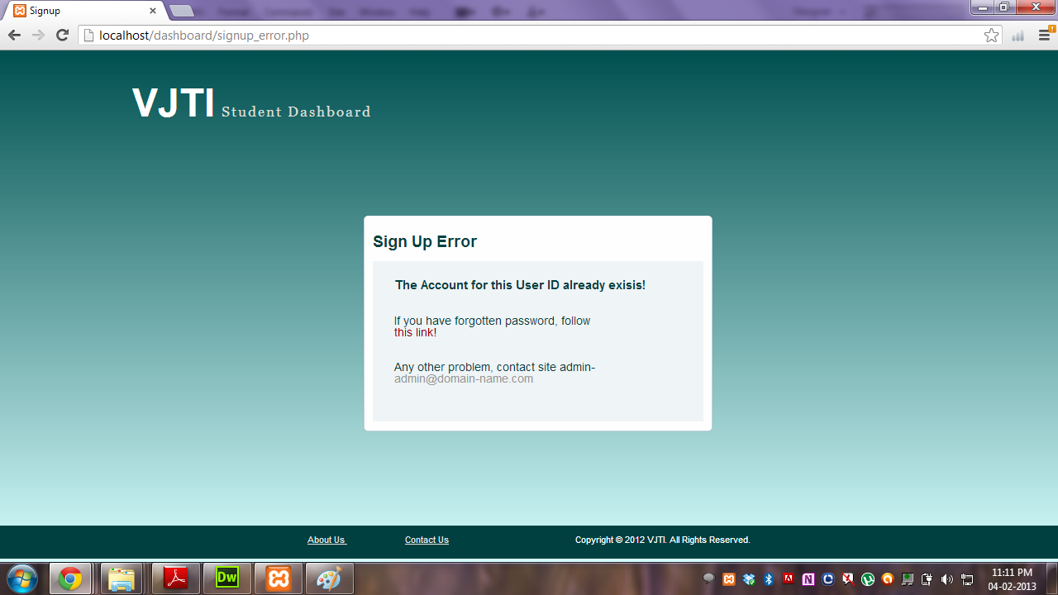

**Login**

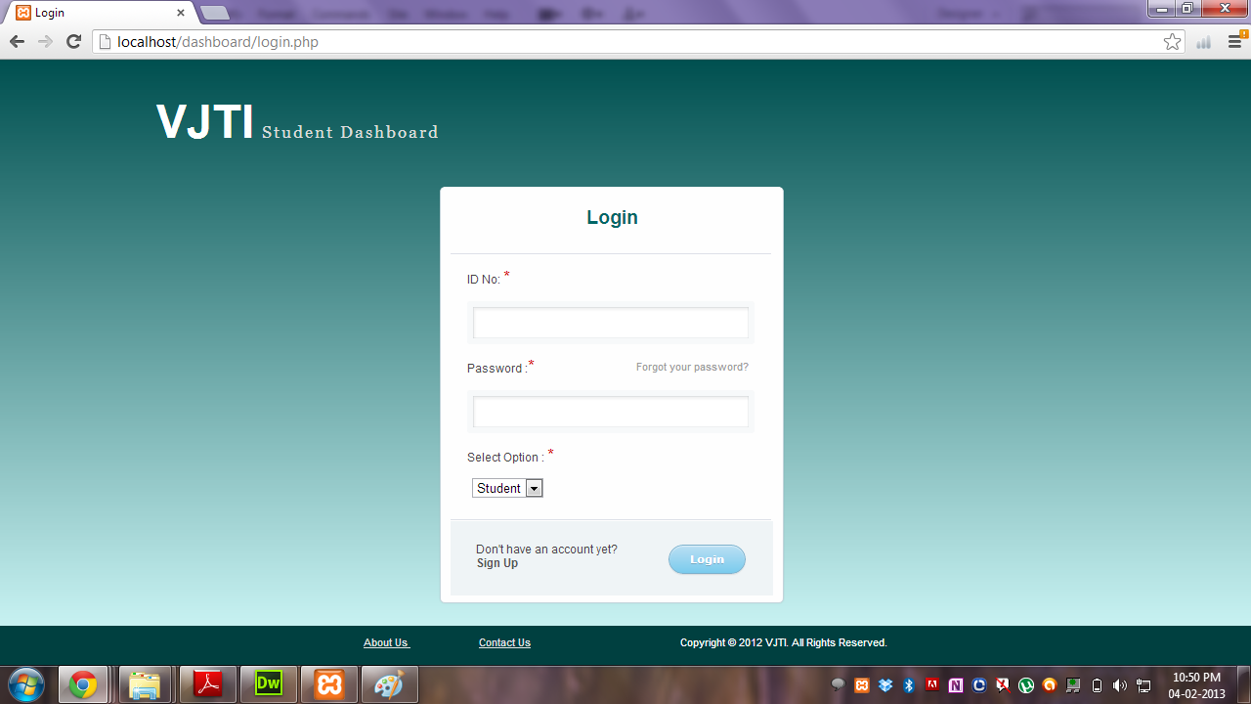

**Homepage**

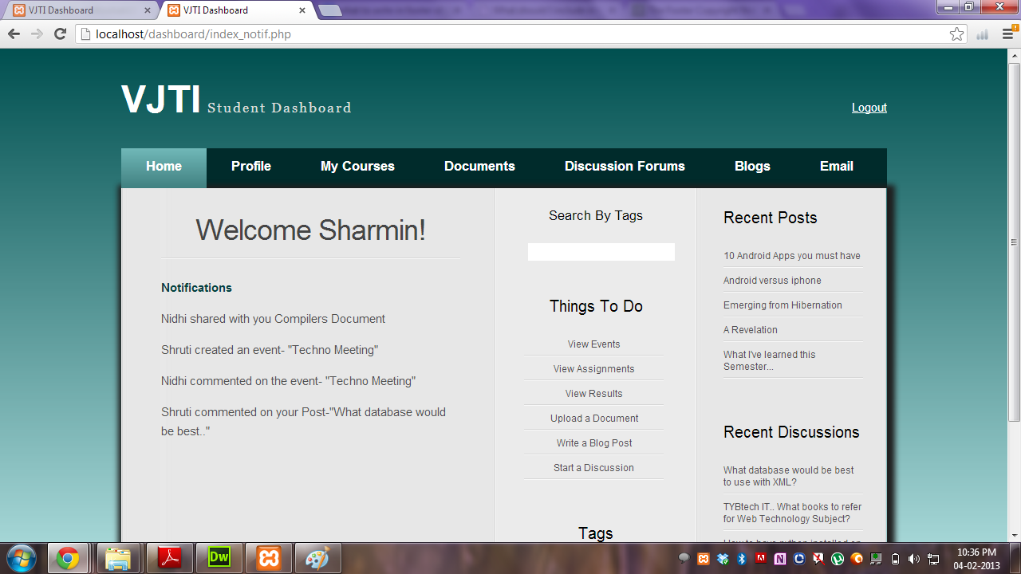

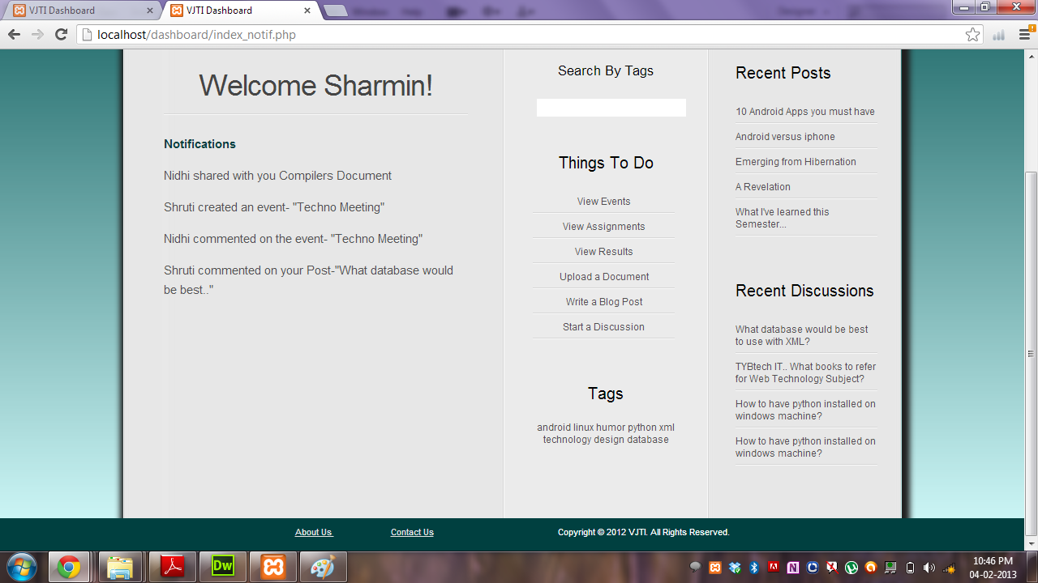

**Homepage**

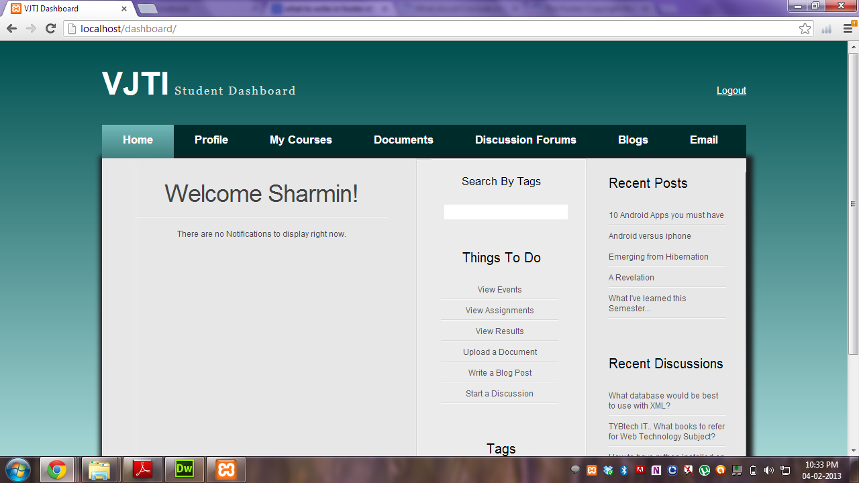

**Personal Documents**

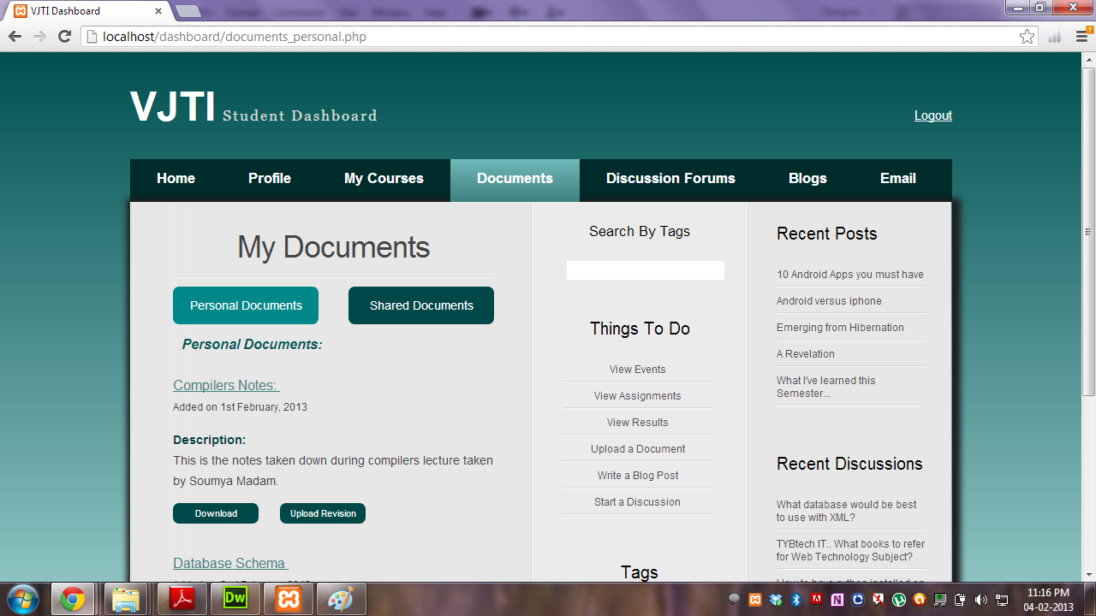

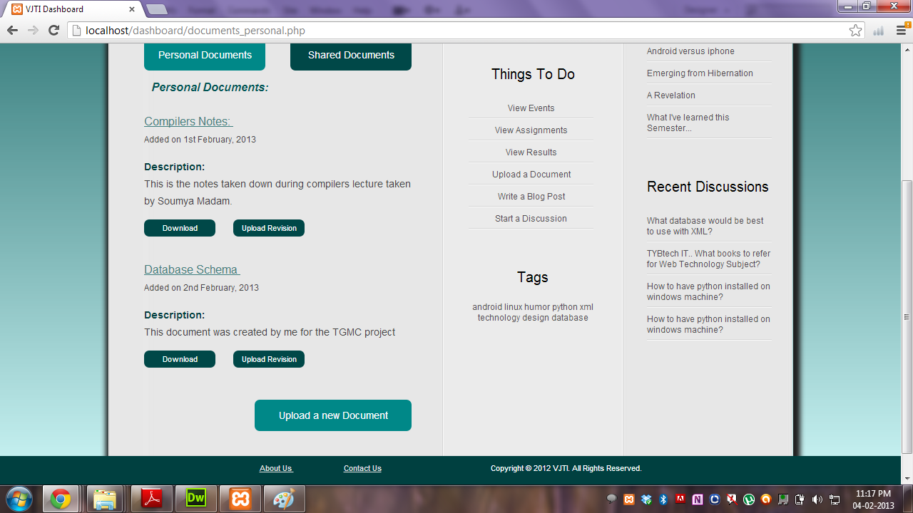

**Shared Documents**

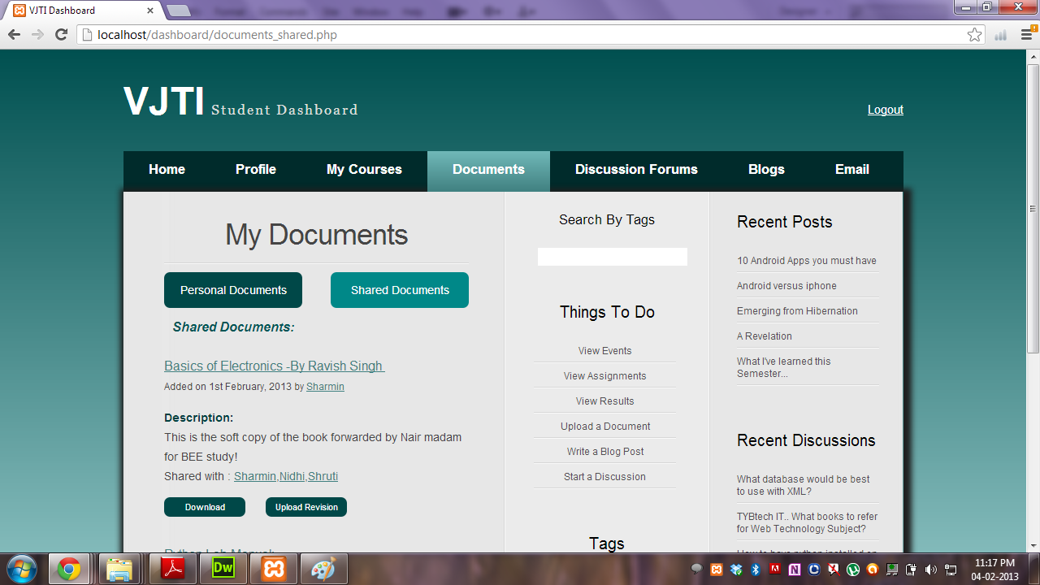

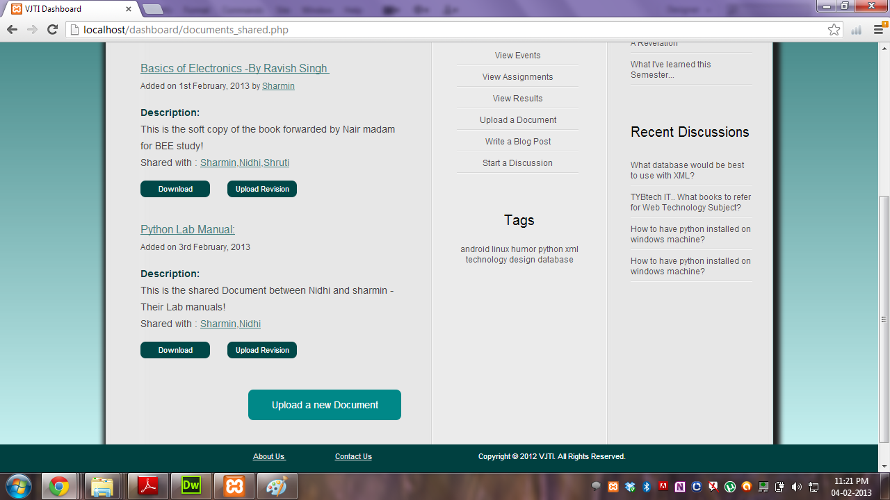

**Forums**

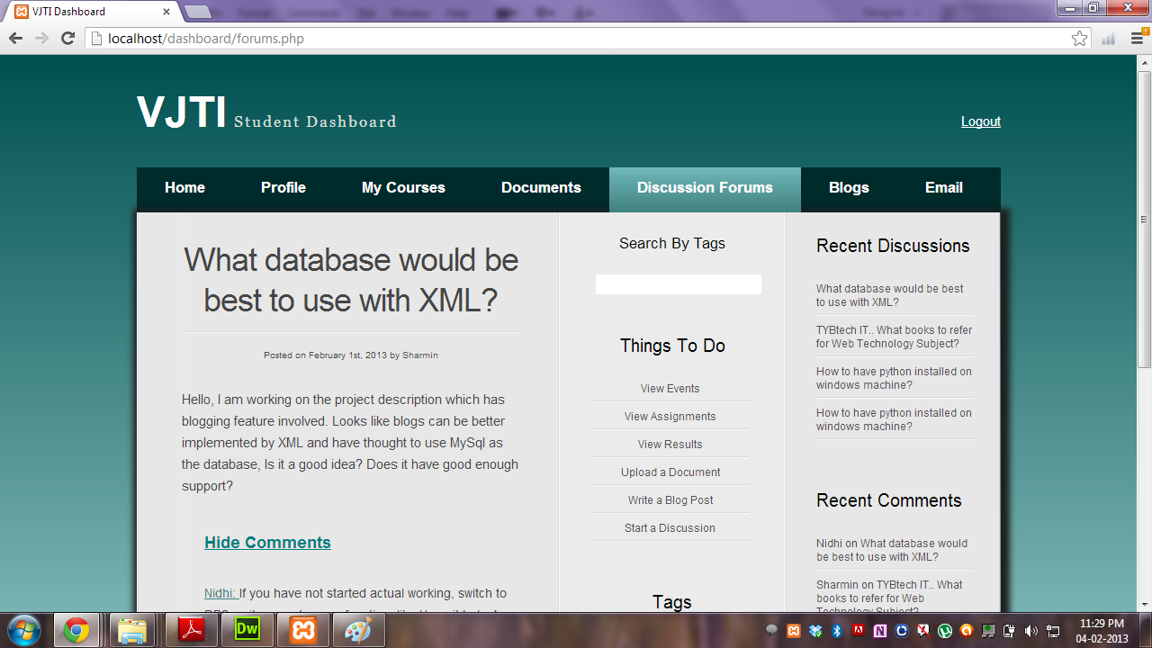

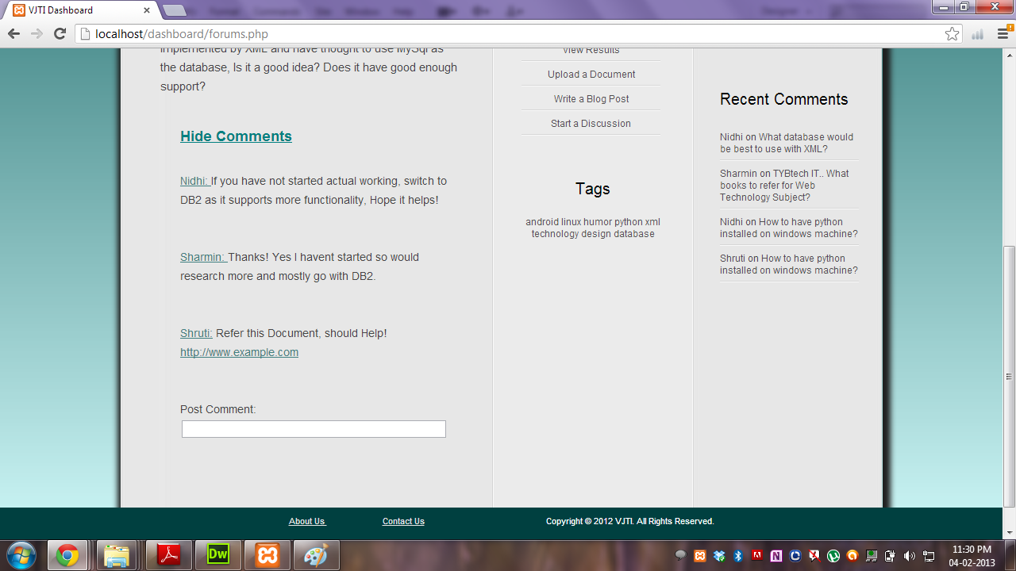

**Blogs**

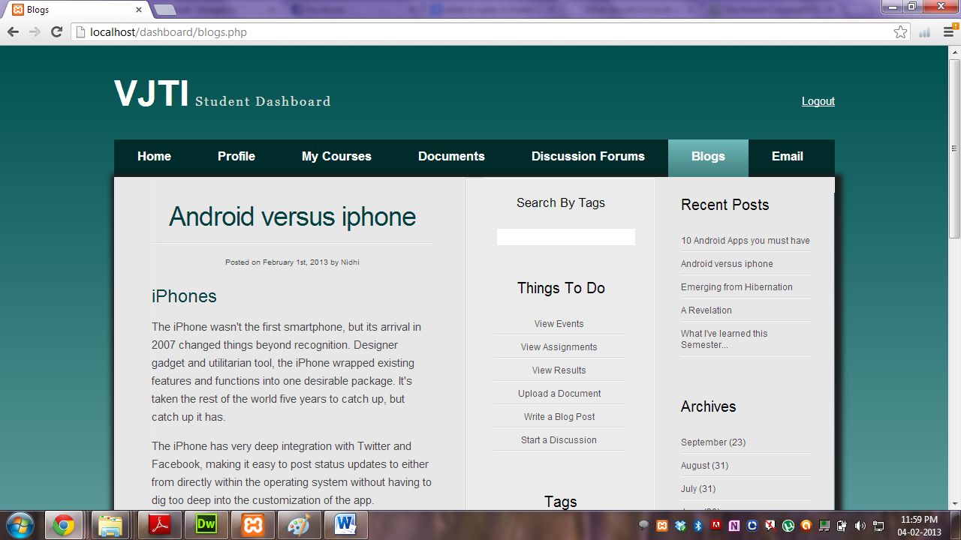

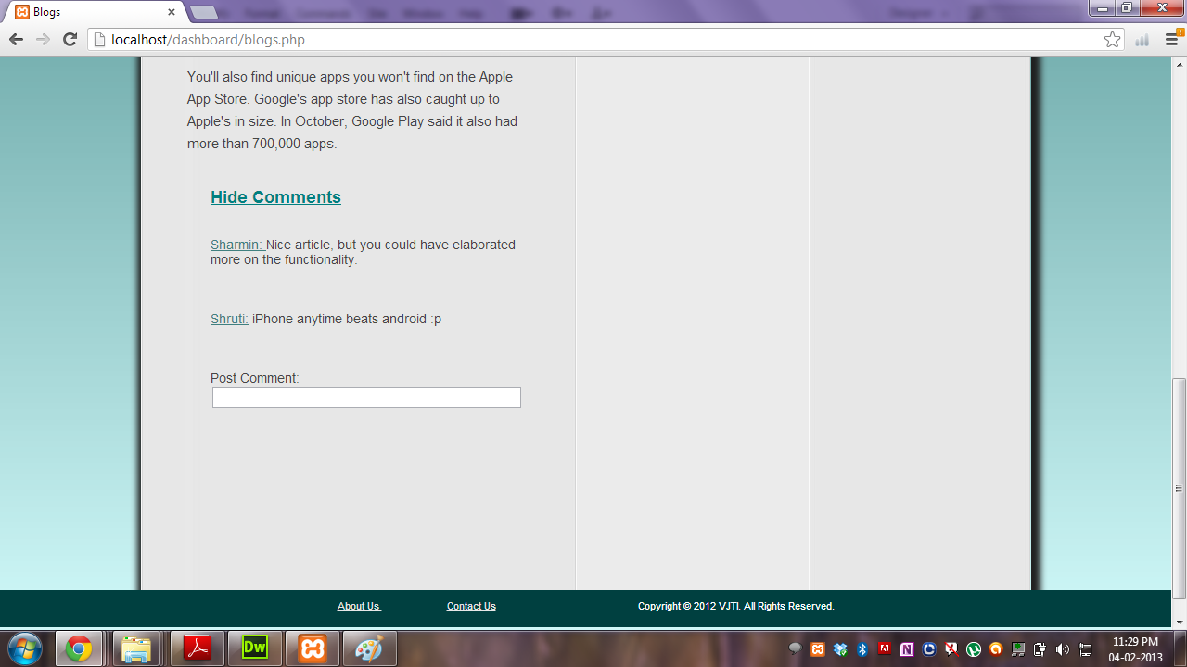

**Relation between web pages**

**Login:**

The user enters the userId, password and selects one of the options: student or teacher.

If the username, password and profession combination is correct, then the user is logged into the system.

**Signup**:

The user enters the following details for signing up.

* Student: First name, last name, userId, email address, password, mobile number, branch and year.
* Teacher: First name, last name, userId, email address, password, mobile number, department, post and qualifications.

If the userId is an invalid Id, or an account with that Id already exists, then the signup process does not complete.

**Homepage:**

The homepage provides links to the user profile, courses, documents, forums, blogs, etc.

The homepage also displays notifications.

A user receives a notification in the case of following events:

* New event created.
* Comment posted on an event that the user has been invited to.
* A document shared with the user.
* A new version of a shared document uploaded.
* Assignment added.
* Results published.
* Comment posted on a blog posted by d user.
* Comment posted on a discussion started by the user.
* Comment posted on an event on which the user had previously commented.
* Comment posted on a post on which the user had previously commented.
* Comment posted on a dicussion on which the user had previously commented.

**Profile:**

The user can view his/her profile and edit as required.

**Documents:**

A user can upload and download personal or shared documents.

The user can also upload a revised version of a shared document.

**Discussion Forums:**

A user can start, reply to and view recent discussions.

**Blogs:**

A user can post, comment on and view recent blogs.

**Database schema**

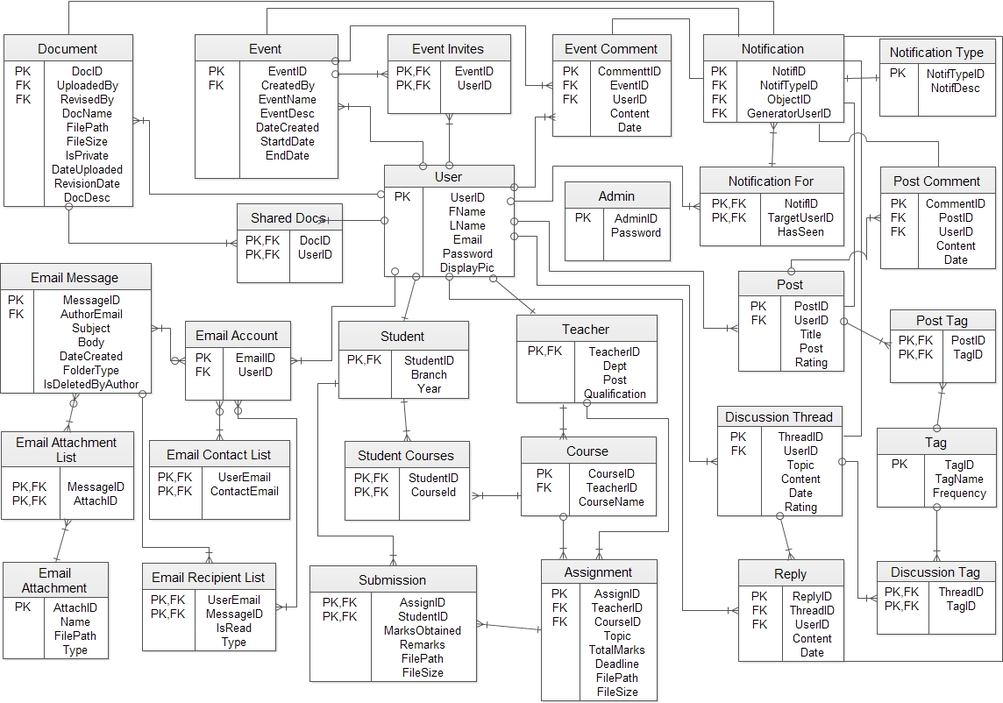

**Functionalities Covered:**

1. User Sign Up
2. User Authentication
3. Login Facility
4. Personalized Home page of each User
5. Forums
6. Blogs ( Partially implemented )
7. Document manager for each user implemented, but has constraint of no online editing!

We will integrate or enhance this functionality to overcome the constraint.

**Functionalities to be covered:**

1. Events / Activities /Assignments
2. Email Client
3. And details which student would use – Syllabus, timetable etc.

**Future Scope:**

1. Email and Mobile SMS support on notifications, notice etc.
2. Chat Messenger.